**Lab 4 Report**

Student number: 12161762

Name: LEE YEONG JUN

**#1**

<Code>

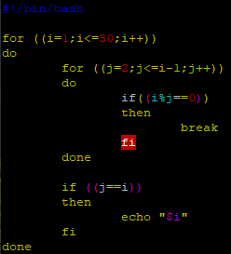

<Result>

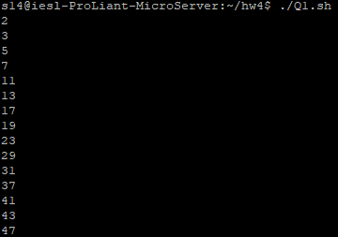  
The variable i is set to the dividend, and the variable j is set to the divisor. The range of variable i is from 1 to 50, and the range of variable j is set from 2 to i-1. Originally, it should be set from 1, but since all numbers are divisible by 1 and are also divisible by themselves, j is set from 2 to i-1 except for 1 and i.

The variable i was repeated with for statement while increasing by 1 from 1 to 50, and the variable j was repeated with for statement while increasing by 1 from 2 to i-1. Do ‘Break’ if i is not a prime number. Otherwise, print i.

**#2**

<Code>

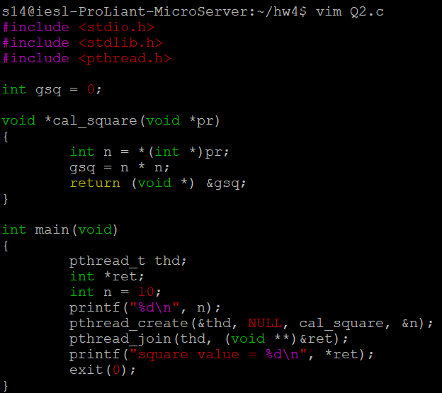

<Result>

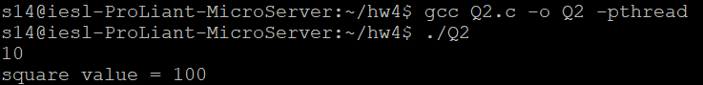

The global variable gsq is set as a variable that stores the square of the variable n in void *cal_square, and &gsq is converted to void type and returned. Also, since pthread_join contains a double pointer as a parameter, the pointer *ret is set in main and &ret is typecast as a double pointer.

When executing it, I tried to execute it with ‘gcc -o run Q2.c’, but due to an undefined reference error, I changed the command to ‘gcc Q2.c –o Q2 –pthread’ and ‘./Q2’ and executed it.